Big Mountain Resort

# Introduction

Big Mountain Resort’s (BMR) was open 72 years ago in the state of Montana, with a skiable terrain of 3,000 acres divided in 4 terrain parks and 600 acres avaible for night skiing. Beyond the 333mm average snow fall, there are 600 acres served by snow making. The peek is 6.817ft high and the base is at 4.464ft providing a vertical drop of 2.353ft. The lift facilities have 3 fast Quads, 2 Quads, 6 triples, and 3 surface, totaling 14 chairs for the 105 trails with the longest one running for 3.3 miles. Last year the resort was open for 123 and received 350K visitors, and the same is expected for the current season.

For this season the resort added a new operational expense with the installation of the new lift, then we reviewed the pricing strategy to cover the new cost and checking the price elasticity to maximize the returns.

The relevance of all the facilities and the competitors’ pricing were considered while developing the new price strategy aiming to increase the confidence in the correct pricing decisions to support future facility investment plans based on projected revenue.

# Data Wrangling

The data available considered BMR facilities and characteristics as well the competitors info totaling 27 features of 330 resorts. For the data completeness, it was missing just over 50% of the fast eight information, 43% of night skiing and 15-16% of the ticket value.

Our target was the Adult Weekend price, currently at $81. We selected the Weekend price with less missing rows and when it was missing and Weekday prices were available we considered this one. Rows without both prices were removed leaving 277 entries for the final dataset.

Some cleansing of the data was necessary but the information necessary to validate such issues was easily available online or were obvious typos such as the Opening Year or Skiable terrain. The columns fastEight was removed (just one value different of zero) and

The majority of the resorts are located at New York state, but there are resorts all over 38 regions and 35 states. The ticket price distribution showcases that the price ticket is related to the geographical location of the resort. BMR ticket of $81 is an outlier for Montana however it is an average price when compared to resorts of other states with equivalent facilities and options.

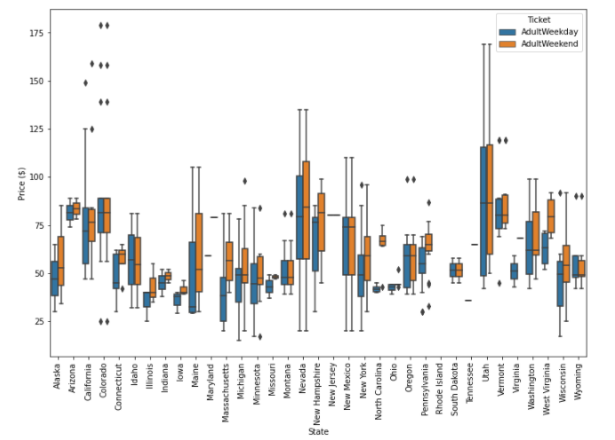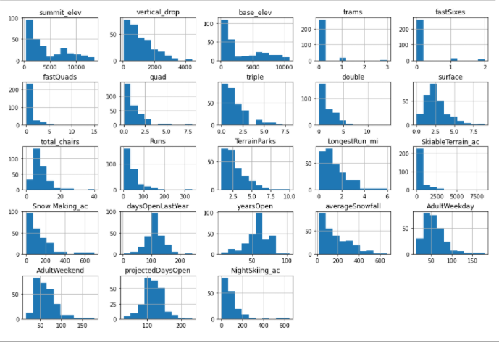

# Exploratory Data Analysis

We explored the 22 numerical and 3 categorical features and their correlation to the price. New York has most of resorts, but they are smaller, while Montana has the 4rd largest skiable area in the country but it is not populous.

Principal Component Analysis (PCA) showed that two components are responsible for 75% of the variance and if we consider 4 components we have 95% of the variance of the price, however when you do a scatterplot they don’t reveal any pattern. So we can utilize all the states to model our price because there is no clear pattern for the pricing and the states where they are located.

We created some ratios related to the business and performed a correlation analysis. Features such as vertical drop, fastQuads, Runs, Snowmaking_ac, and total_chairs have a strong correlation with the price. The

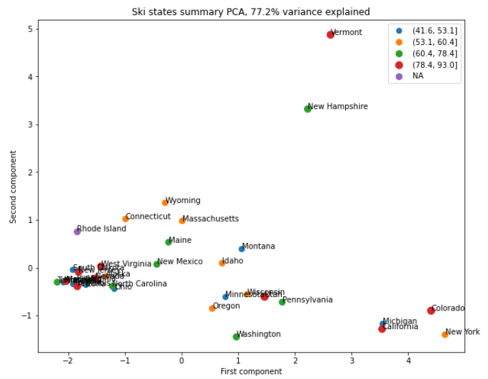 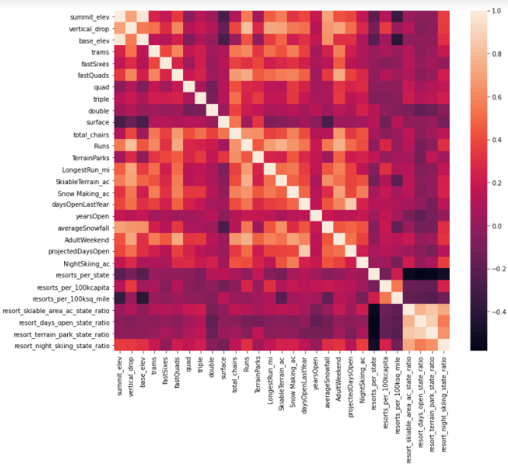

# Modeling

# Conclusion